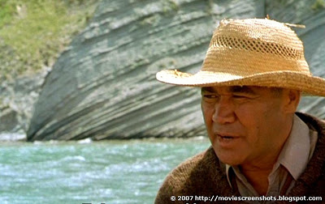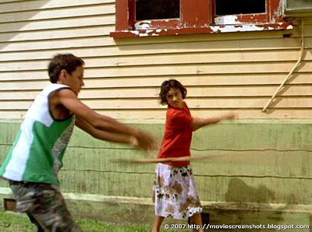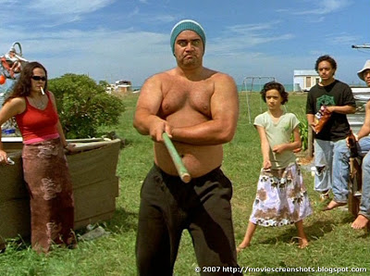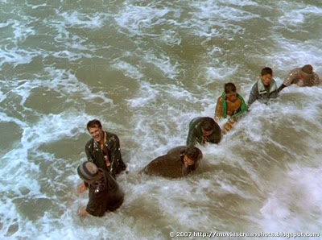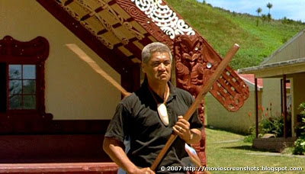

Whale Rider Story Board

Resource - <http://moviescreenshots.blogspot.co.nz/2007/03/whale-rider-2002.html>

Director Niki Caro used a Closed Up (CU) to show the Emotion of Koro Paka. He is talking to the Cultural Class boys about finding a leader. Before throwing his whale tooth taonga over-board. He is looking over-cross the vast open ocean.

Director Niki Caro used a Full Shot (FS) to show Pai winning a duel with taiaha between one of the cultural school boys. Showing from what Pai learnt from Uncle Rawari (Shot Above) had paid off. Pai is showing what kotiro are capable of achieving.

Director Niki Caro used a Full Shot (FS) to show Uncle Rawari’s taiaha skills. In the background you see Pai following her uncle. In the foreground you see Uncle Rawari performing traditional taiaha movements. Uncle Rawari shows Pai how to use a taiaha because her Koro Paka wouldn’t teach her.

Director Niki Caro used a Mid-Shot (MS) to show the emotion on Koro Paka’s Face and body tension. Showing the anger and strength. He is staring at the boys participating in the Cultural School. Boiling fear upon the boys. He is showing how to properly use the Taiaha.

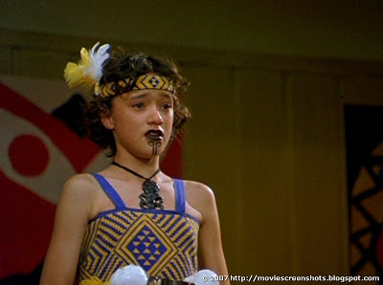

Director Niki Caro used a Close Up (CU) to show the emotion reflecting on Pai’s Face. He was capturing the tears running down her face because of her Koro Paka not showing up on her award winning evening. Koro notices Whales Beached and didn’t arrive. She sings while crying. Her speech spoke many words.

Director Niki Caro used a Long Shot (LS) to show the complete body of people coming composed as one to help the whale back towards the sea. Showing the unity and strength of the community paired with a tractor. Men and Women uniting as one to complete a huge task.